Main Game Screen Interface

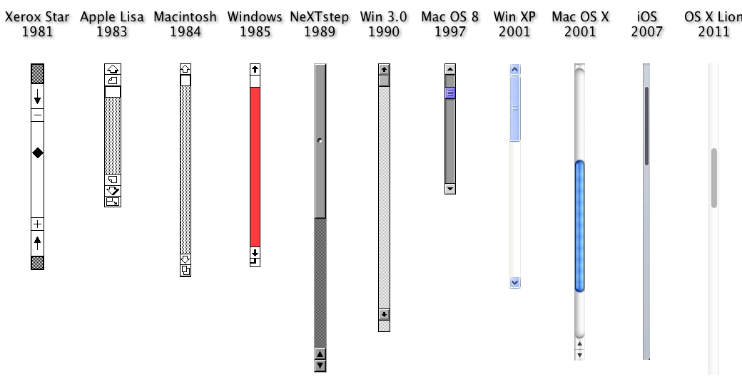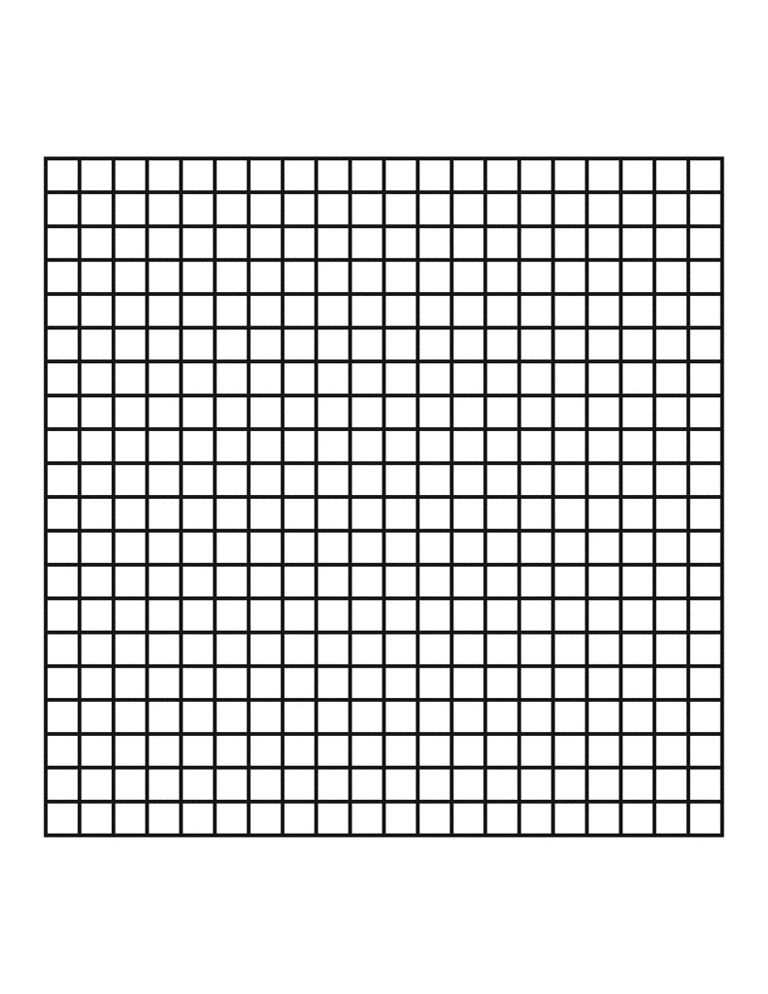\

**Place Block**

**RED Player’s Turn**

Quit Game

**2**

blocks left

If there is more than one player, more than one of these windows will open, with the game board and selection panes adjusting to the other player(s). The players will have to switch windows between turns.

Main Menu

Graphics will be added for user appeal, but these are the options that will be available to the user on the main menu.

Quit

Instructions

Watch a Replay

Play Game!

Blokus

Finished Game

RED won. You finished with -10 points, YELLOW finished with a score of -20 points, and GREEN finished with a score of -30 points. If you would like to see a replay of this game, use the following transcript:



P1 4 25 5

P2 4 12 4

P3 6 13 9

P4 29 1 20

P1 4 19 19

When a game is finished, a dialog box pops up with the option to copy a transcript of a game’s moves if a user wants to replay a game.